To whom it may concern | Norėdami įvesti datą, spustelėkite arba bakstelėkite čia. | Nr. VD-2-669

INVITATION TO THE SHOOTING COMPETITION

On the behalf of Lithuanian Practical Shooting Sport federation, I kindly invite you to visit Lithuania during from Norėdami įvesti datą, spustelėkite arba bakstelėkite čia. until Norėdami įvesti datą, spustelėkite arba bakstelėkite čia. in order to participate in the Shooting Match named "Norėdami įvesti tekstą, spustelėkite arba bakstelėkite čia."
Show this invitation and gun permit to the officers while crossing the border.
Names o f invited Shooters:
Norėdami įvesti tekstą, spustelėkite arba bakstelėkite čia.

Federacijos Prezidentas | 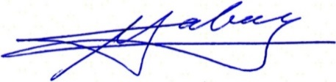 | Vaidas Sabaliauskas

